I. Install 3 virtual machines version of Ubuntu 14.05 desktop i386 (2 servers and one balancer)

II. Take as a basis the complete mashine ub_14_32_421.ova, install its three versions - for server 1 (webserver_1), server 2 (webserver_2) and for the load balancer (loadbalancer). You can go to the "Doing work" section (hereinafter, here only a short implementation plan).

III. Configure them. Attention - an example of setting - in the section "Doing work". Result here:

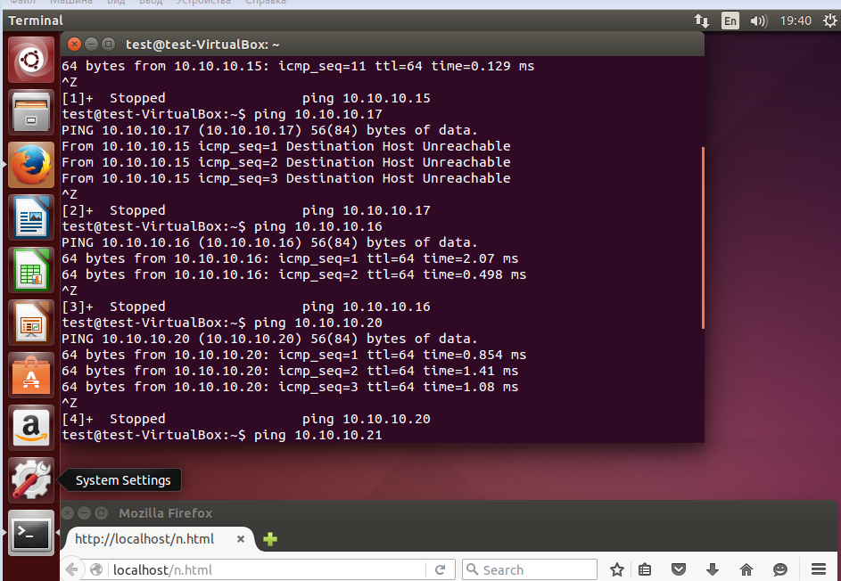

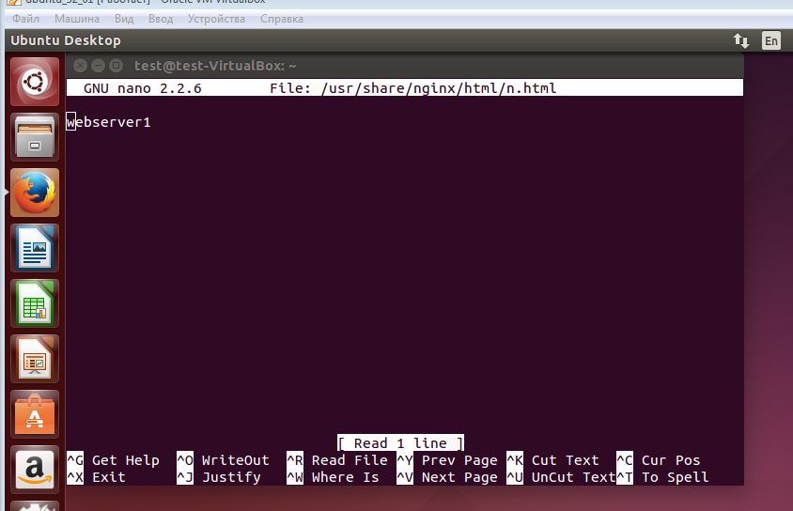

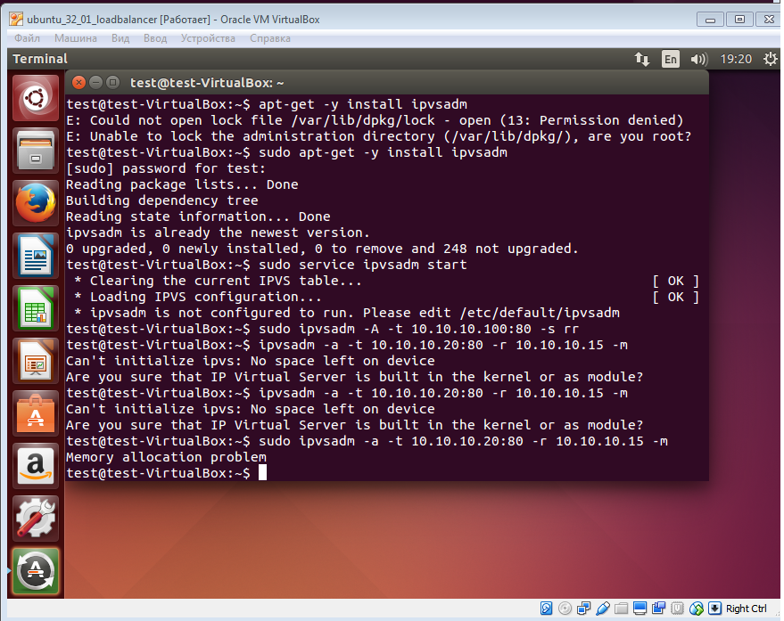

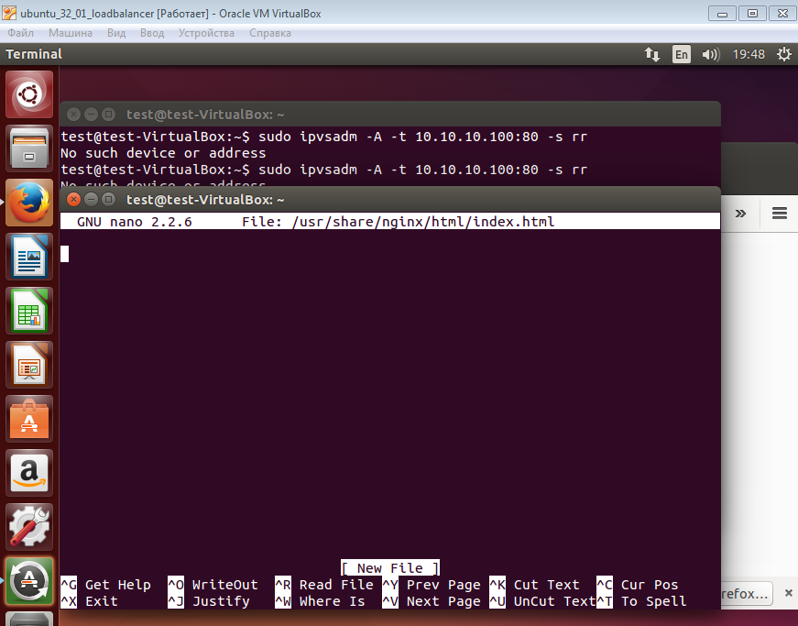

Here the mistake in instruction

Bring the screen (s) of screen (s) in this place:

Install the software on loadbalancer

Installing ipvs

Sudo apt-get -y install ipvsadm

Running

Sudo service ipvsadm start

Create rules for balancing

Sudo ipvsadm -A -t 10.10.10.100:80 -s rr

**SHOULD BE**

Sudo ipvsadm -A -t 10.10.10.20:80 -s rr

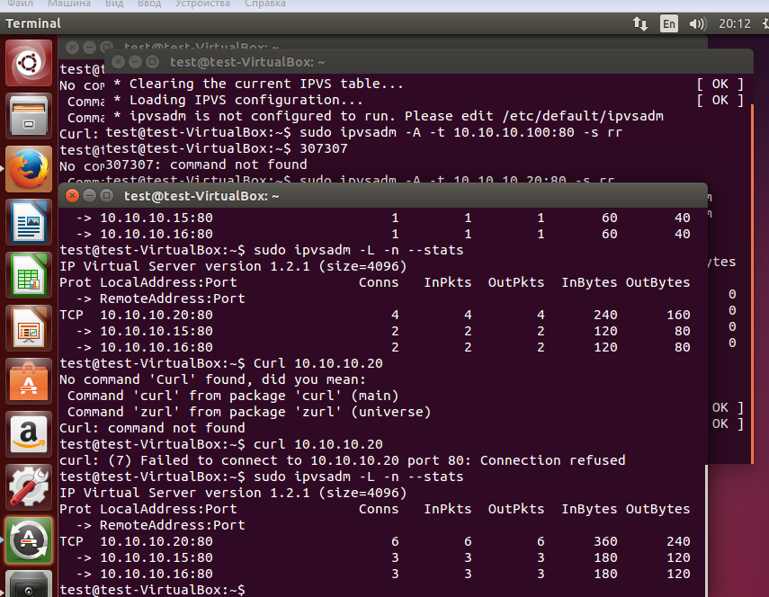

**In last action one more error here**

**sudo ifconfig lo:0 inet 10.10.10.20 netmask 255.255.255.0**

**should be**

* **sudo ifconfig lo:0 10.10.10.20 netmask 255.255.0.0 broadcast 10.10.10.20**

